FLIGHT BOOKING SYSTEM

Software Engineering Project

Report – Phase I

By

Abhishek B Jangid (1301002)

Md Syed Ahamad (1301030)

Indian Institute of Information Technology Guwahati

**INTRODUCTION**

Flight Booking System is an application software for booking flight ticket supporting direct contact with the customers. It is eventually evolved into Computer Reservation System (CRS).

The document contains the list of requirements for the project. It will help in analysing the whole structure of the project. It also aims for people to understand the details of the application visually. This is the phase – I report documentation.

**REFERENCES:**

* <https://en.wikipedia.org/wiki/Airline_reservations_system>
* <http://people.cis.ksu.edu/~kaavya/MSE%20PROJECTPAGE.htm>
* ArgoUML for use case diagram

**PRODUCT DESCRIPTION**

**Features:**

Client Site:

-Home Page

-Sign in and Sign up

-user Details

-Flight search

-class

-date

-source/destination

-domestic/international

-one way/round trip

-no. of tickets

-Flight booking

-select Flight

-make Payment

-credit/Debit Card

-ticket confirmation status

-Cancel ticket

-Booking instructions

-Complain/contact the company.

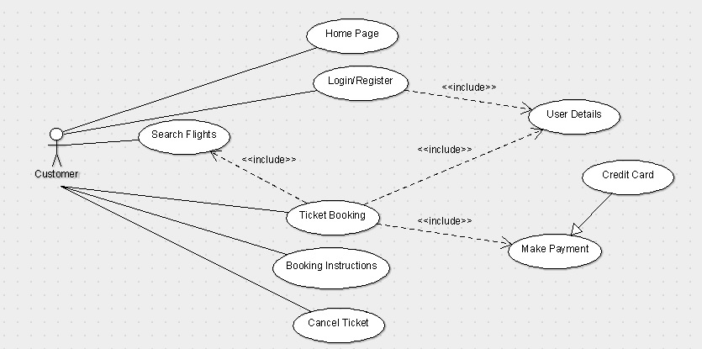Fig. 1 Use case – Customer site

**Home Page**: Like all the other flight booking websites available online, the user can access the user home page of the Flight Booking System website, after he logs into the system. Here, he can search for flights (schedules, fare, source/destination etc.).

**Login and Register**: The Flight Booking System also comes with the customer registration details page, where the customer can enter his details and register. He can also create a 'username' and 'password'. Moreover, he will also be able to modify his details later on.

**Search Flights**: The customer can also search for the flights available and can find the best flight according to his schedule.

**Ticket Booking**: The customer can reserve his place on the flight by purchasing a ticket. To book a ticket he has to make payment via credit/debit card by providing his credentials.

**Booking Instructions**: The website also provides instructions to the customers on how to book flight tickets along with the different packages. This system provides some of the best offers at the present time.

**Cancel Ticket**: If user is no more interested, then this particular system also allows customer to cancel his ticket which was booked before.

Administrator Site:

-Login/Logout

-Add/modify customers’ info

-Add/modify flight info

-Cancel/Modify reservation

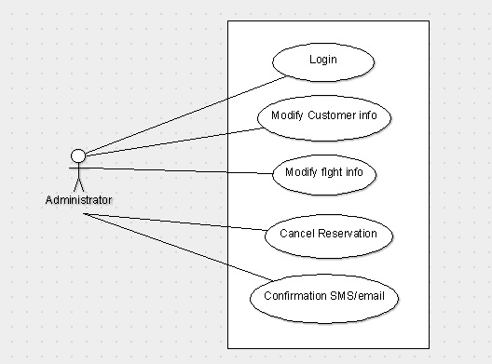-email/SMS confirmation.

Fig. 2 Use case – Admin site

**Login:** It is same as customer login but at admin level. Admins are privileged to modify (add/delete/change) customer’s info, flight info etc. They are the actual stakeholders of the product.

**Add/modify customers’ info:** Admin controls the customers’ activity and they have sole right to modify database related to customer.

**Add/modify flight info:** Admin should update the changes flight schedules from time to time. Moreover, fare details for each schedule is also updated. He can update cancellation of flight schedule due to some reason.

**Modify/Cancel Reservation:** Admin can cancel reservation or modify when customer requested to do so or for another reason.

**Confirmation SMS/email:** This is generated to send the booking Id or ticket No. of which flight user booked. This may also tell user about the confirmation of the ticket (confirm/pending etc.)

**SPECIFIC REQUIREMENTS:**

**External Interfaces:**

* **User Interface**
* **Hardware Interface**
* **Software Interface**

**User Interface:**

Flight Booking System consists of two types of users – Customer and Admin. Both uses graphical user interface. They can excess the application with different different privileges given above in the feature and use cases.

**Hardware Interface:**

**Software Interface:**

The Product is designed in web based application through jsp, in windows. It will use MySQL for database. It will include HTML, java and JavaScript etc.

**FUNCTIONAL REQUIREMENTS:**

1. **User Registration**
   * **Description:** New user has to register with necessary details to book a ticket.
   * **Actor:** User
   * **Input:** The user has to provide all the necessary details present in the customer registration form of the application.
   * **Output:** All the details entered will be verified and accepted by the system into the database.
2. **User Login**
   * **Description:** Old user logs in to the application
   * **Actor:** User
   * **Input:** The user provides User Id and password for login
   * **Output:** User will be verified for authentication with the provided credentials. If those are matched, user is logged in. Otherwise, application returns login page with message of invalid credentials.
3. **Contact Us**
   * **Description:** User contacts the company for any information or any complaint.
   * **Actor:** User
   * **Input:** User enters the complaint information with his credentials.
   * **Output:** The Application generate a complaint Id after user is verified and information is provided to Admin to resolve.